DISHES AND THEIR ALLERGEN CONTENT After School club

DISHES | 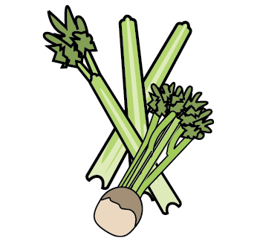 |  |  |  |  |  |  |  |  |  | 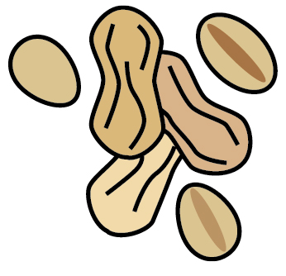 |  |  | 
 | Celery | Cereals containing gluten | Crustaceans | Eggs | Fish | Lupin | Milk | Mollusc | Mustard | Nuts | Peanuts | Sesame seeds | Soya | Sulphur Dioxide
ASDA wholemeal bread |  | Y |  |  |  |  |  |  |  |  |  |  | Y
TESCO muffins |  | Y |  |  |  |  |  |  |  |  |  |  | Y
Asda muffins |  | Y |  |  |  |  |  |  |  |  |  |  | ?
New York bagels |  | Y
Tesco buttery spread |  |  |  |  |  |  | Y
Asda spreadable butter |  |  |  |  |  |  | Y
Dairylea triangles |  |  |  |  |  |  | Y
ASDA baked beans |  |  |  |  |  |  | ?
Hubbards baked beans |  |  |  |  |  |  | Y
Asda spaghetti hoops |  | Y
Stockwell rice pudding |  |  |  |  |  |  | Y
Tesco rice pudding |  |  |  |  |  |  | Y
Stockwell custard |  |  |  |  |  |  | Y
Waitrose rice pudding |  |  |  |  |  |  | Y
Sainsburys mayo |  |  |  | Y |  |  |  |  | Y
Angel delight (strawberry) |  |  |  |  |  |  | Y
Angel delight dessert kit |  |  |  |  |  |  | Y
Fax’s party rings |  | Y |  |  |  |  |  |  |  |  |  |  | Y
Tesco custard creams |  | Y |  |  |  |  | Y
Marmite | Y | Y
Tesco tuna |  |  |  |  | Y
Tesco chickpeas
Asda passata
Asda Tomato soup

Review date: | 20/1/22 | Reviewed by: | Jo Logan |  | You can find this template, including more information at www.food.gov.uk/allergy

